**Name: RIZWAN**

**Roll No:22**

**Batch: MCA**

**Date:22-03-2022**

**NETWORKING & SYSTEM ADMINISTRATION LAB**

**Experiment No.: 1**

**Aim**

Install the latest version of Ubuntu on an Oracle VM Virtual Box.

**Procedure**

## Step 1: [Download VirtualBox](https://www.virtualbox.org/wiki/Downloads) for Windows and install it on the computer.

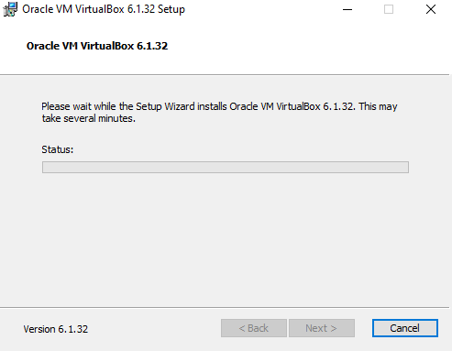

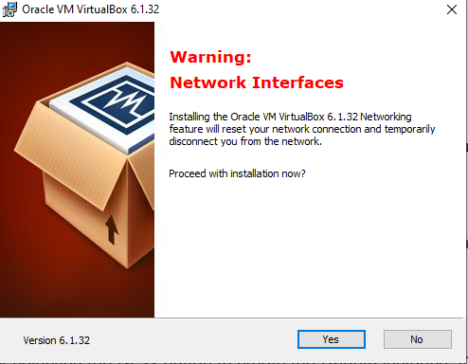

## Step 2: Download the Ubuntu [ISO file](https://www.lifewire.com/iso-file-2625923) you want to install from the [Ubuntu download page](https://ubuntu.com/download/desktop).

## Step 3: Open VirtualBox and select ****New**** in the top taskbar.

## Step 4: Give VM a name, choose ****Linux**** and then choose ****Ubuntu**** as the ****Version****and select ****Next****.

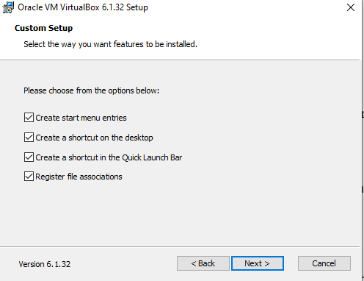

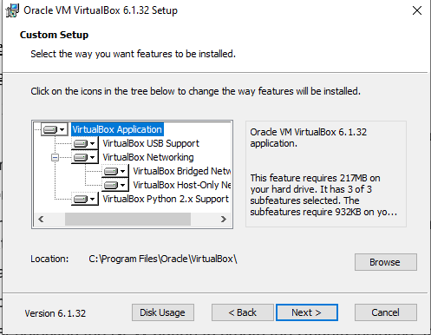

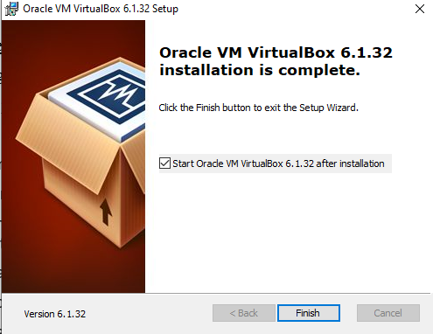

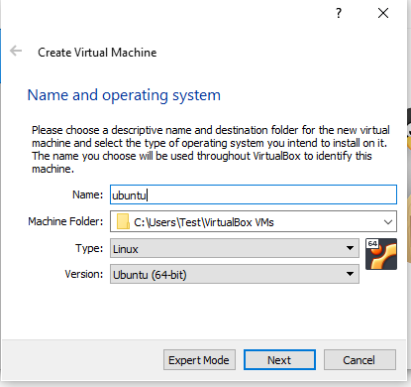

**Step 5:** We want to specify Memory size.

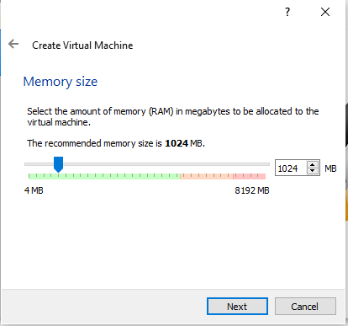

**Step 6:** Check the "Create a virtual hard disk now" option so we can later define our Ubuntu OS virtual hard disk size.

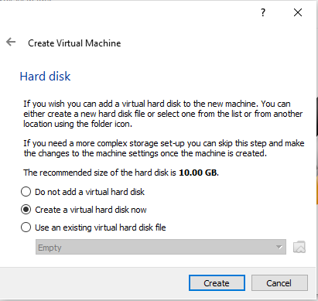

**Step 7:** Select "VHD (Virtual Hard Disk)".

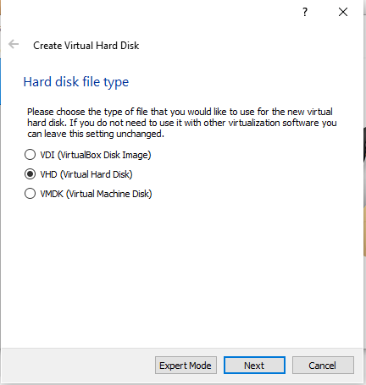

**Step 8:** Next, we'll dynamically allocate storage on our physical hard disk.

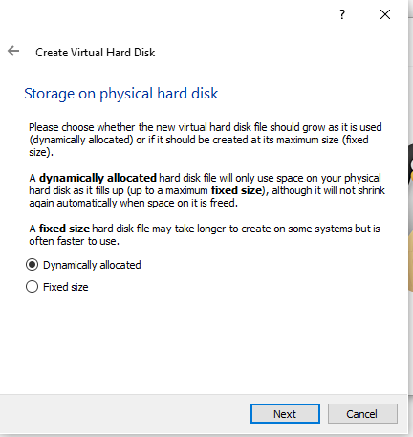

**Step 9:** We want to specify our Ubuntu OS's size. The recommended size is 10 GB, but you can increase the size if you wish.

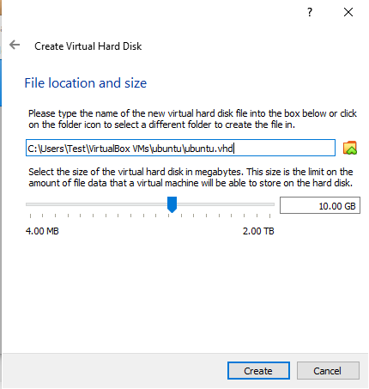

**Step 10:** Select virtual disk image.

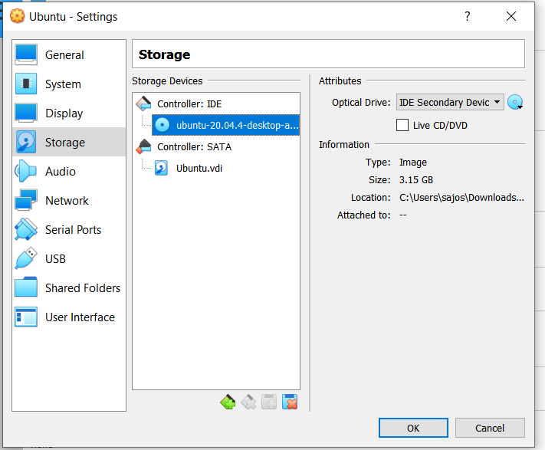

**Step 11**: The name of your virtual machine will now appear on the left side of the VirtualBox manager. Select Start in the toolbar to launch your VM.

**Step 12:** Click Install Ubuntu.

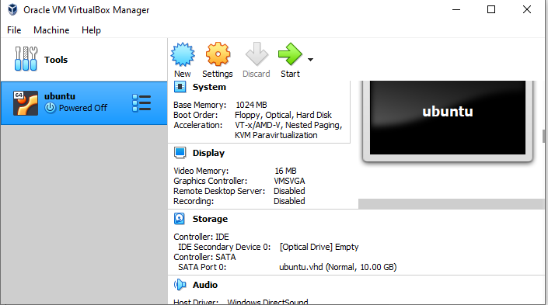

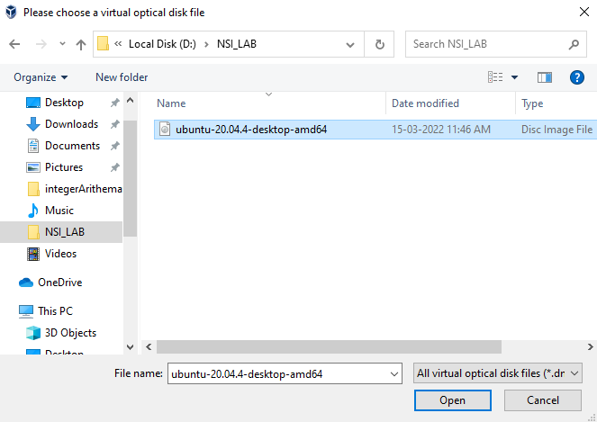

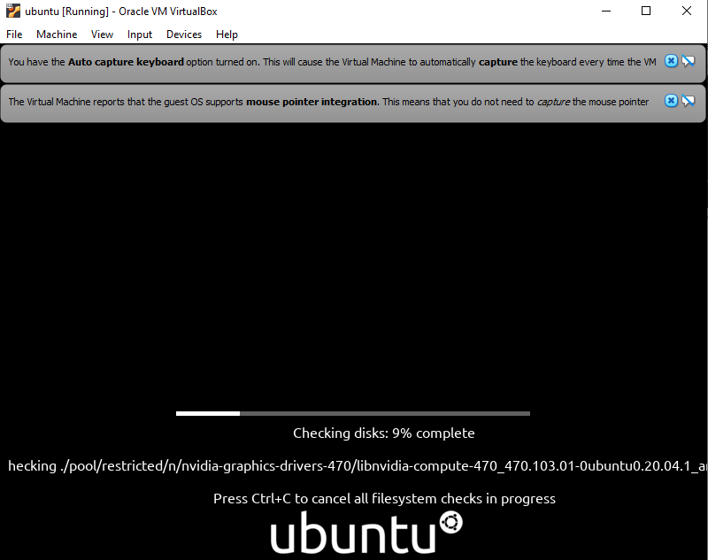

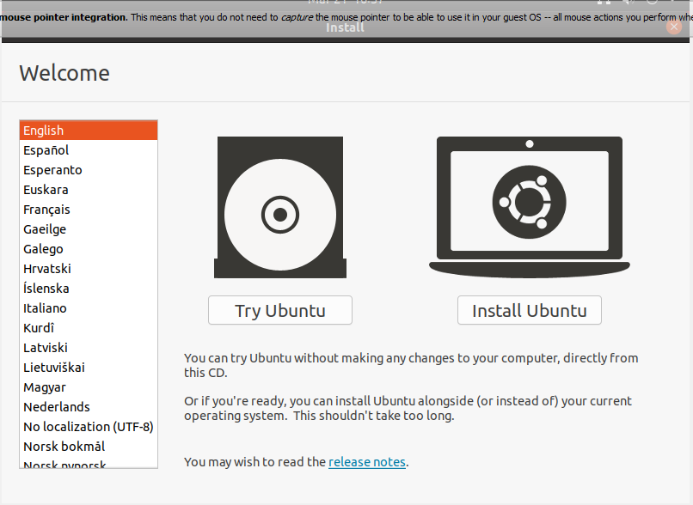

**Step 13:** Select your keyboard layout.

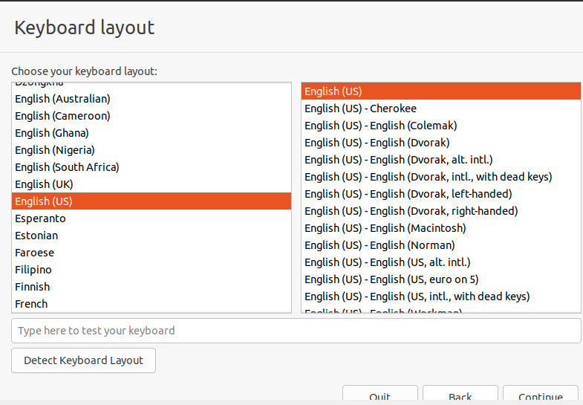

**Step 14:** In the "Updates and other software" section, check "Normal installation" and continue.

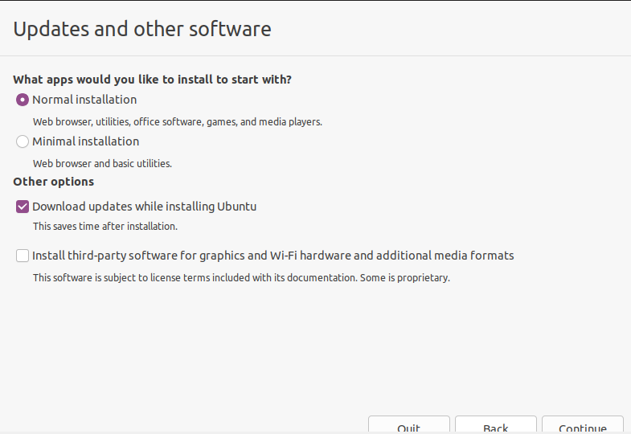

**Step 15:** Choose Erase disk and install Ubuntu and select Install Now, then select Continue to ignore the warning..

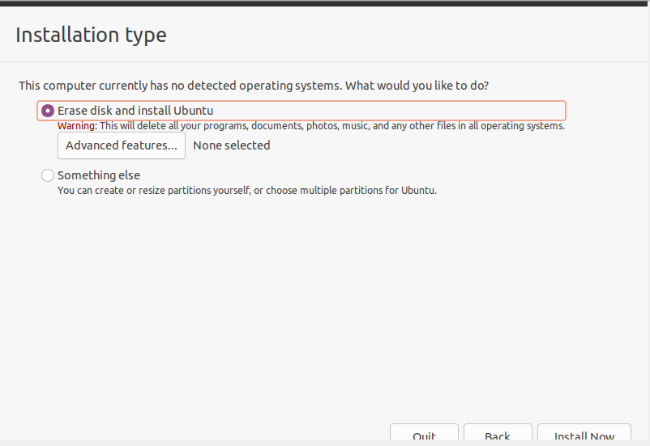

**Step 16:** Choose your time zone on the map, then select Continue.

**Step 17:** Set up your user account and select Continue.

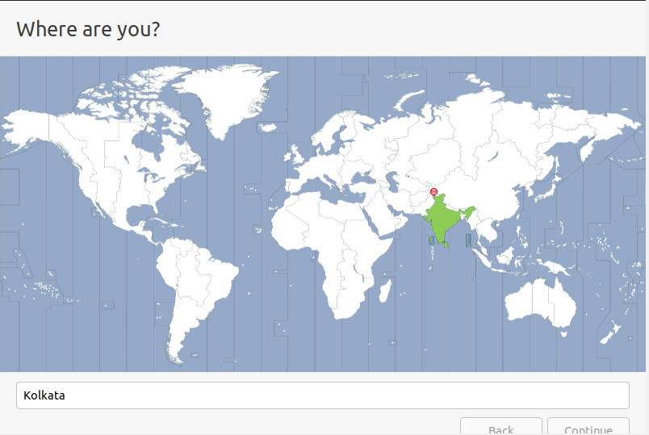

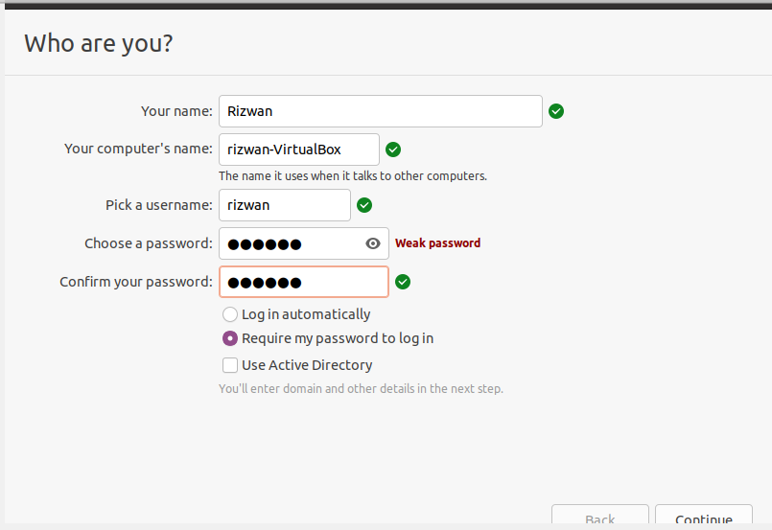

**Step 18:** Installation completed

**Step 19:** Restart your System

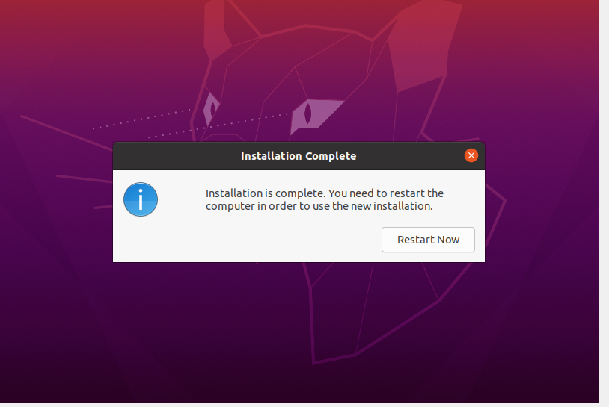

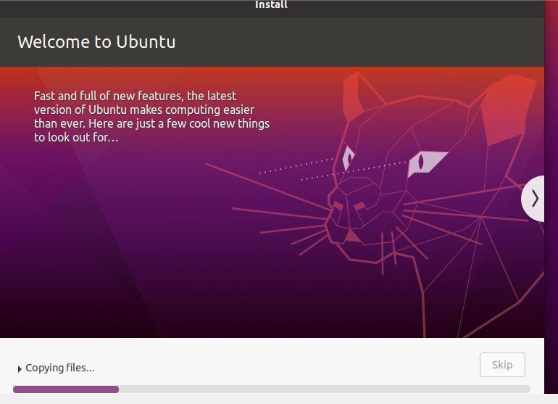

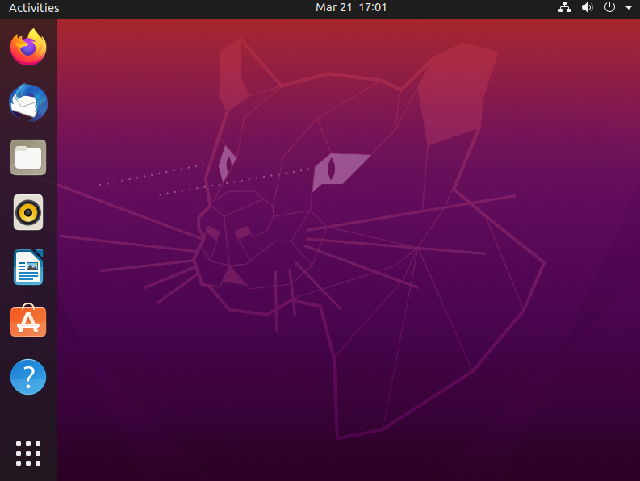

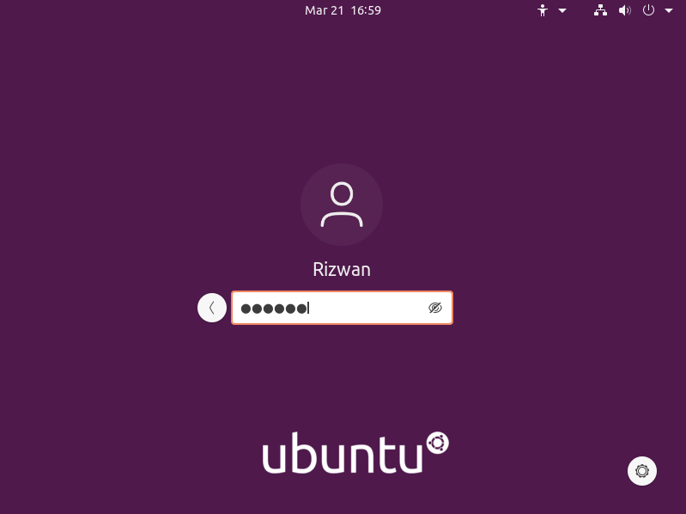

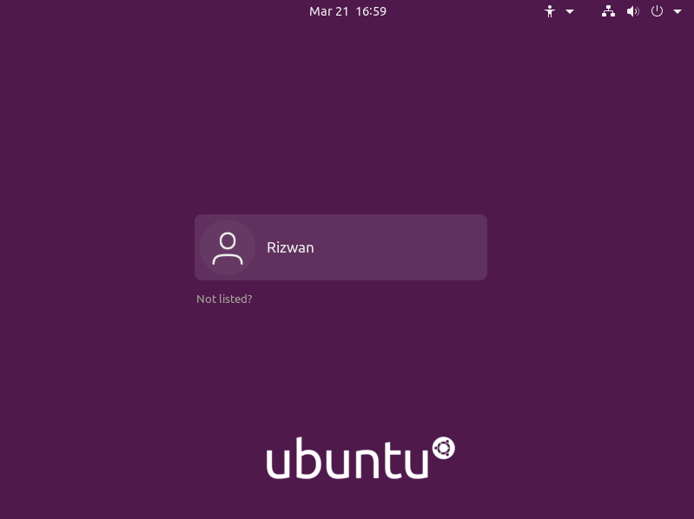

**NETWORKING & SYSTEM ADMINISTRATION LAB**

**NAME:RIZWAN**

**ROLLNO:22**

**BRANCH:MCA**

**DATE:**

**Experiment No.: 3**

**Aim**

Familiarization of the Linux commands.

**Procedure**

**1. pwd**

This command is used to display the location of the current working directory.

**Syntax :-** $ pwd

**Output :-**

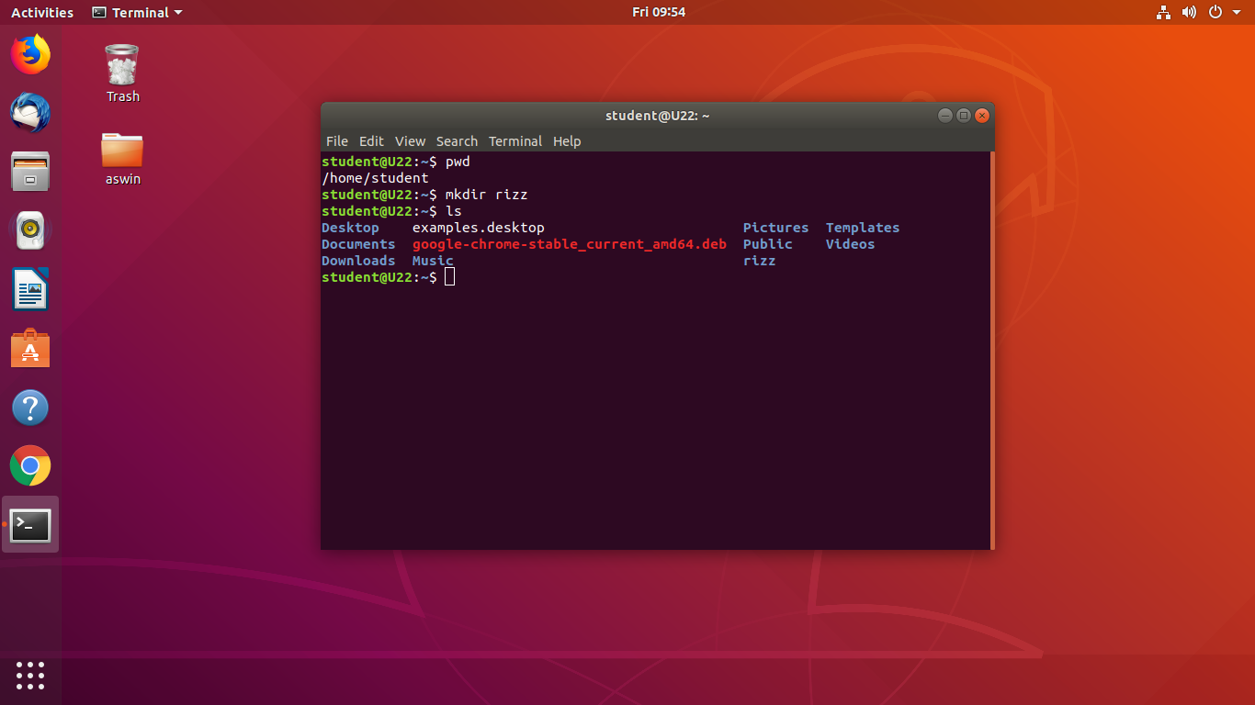

**2. mkdir**

This command is used to create a new directory under any directory.

**Syntax :-** $ mkdir <directory name>

**Output :-**



**3. ls**

This command is used to display a list of content of directory.

**Syntax :-** $ ls

**Output :-**



**5. ls –l**

This command is used to shows file or directory, size, modified date and time, file or folder name and owner of the file, and its permission.

**Syntax :-** $ ls –l

**Output:-**

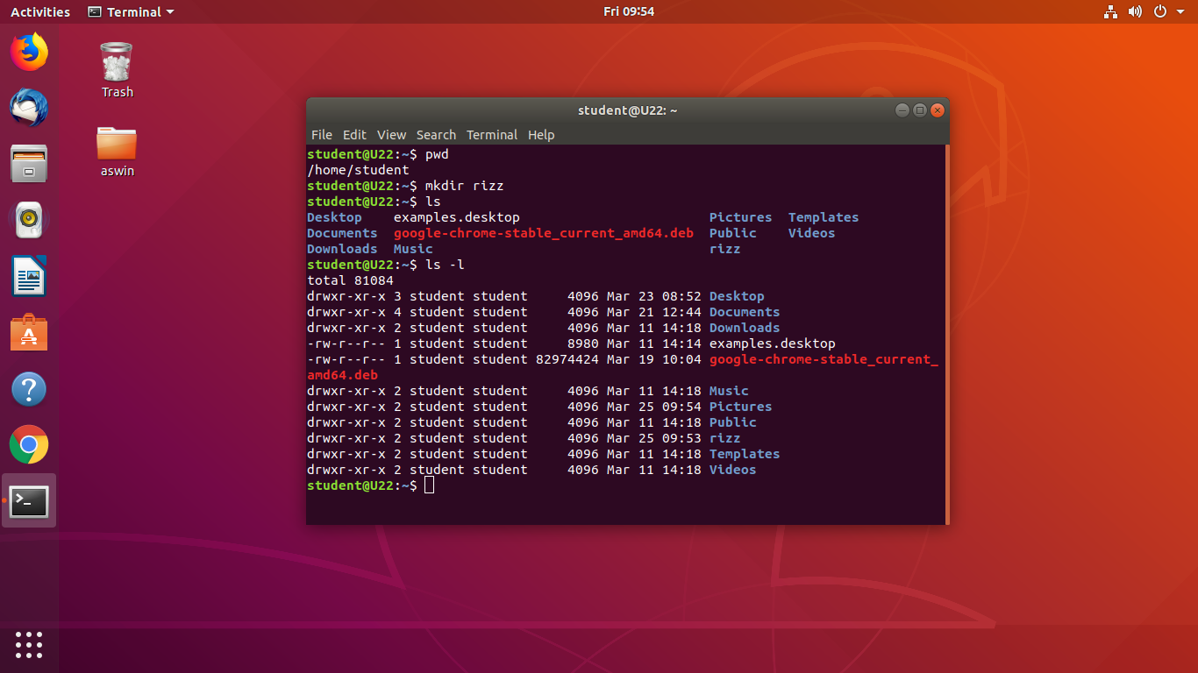

**6. ls –a**

This command is used to list all files including hidden files.

**Syntax :-** $ls –a

**Output :-**

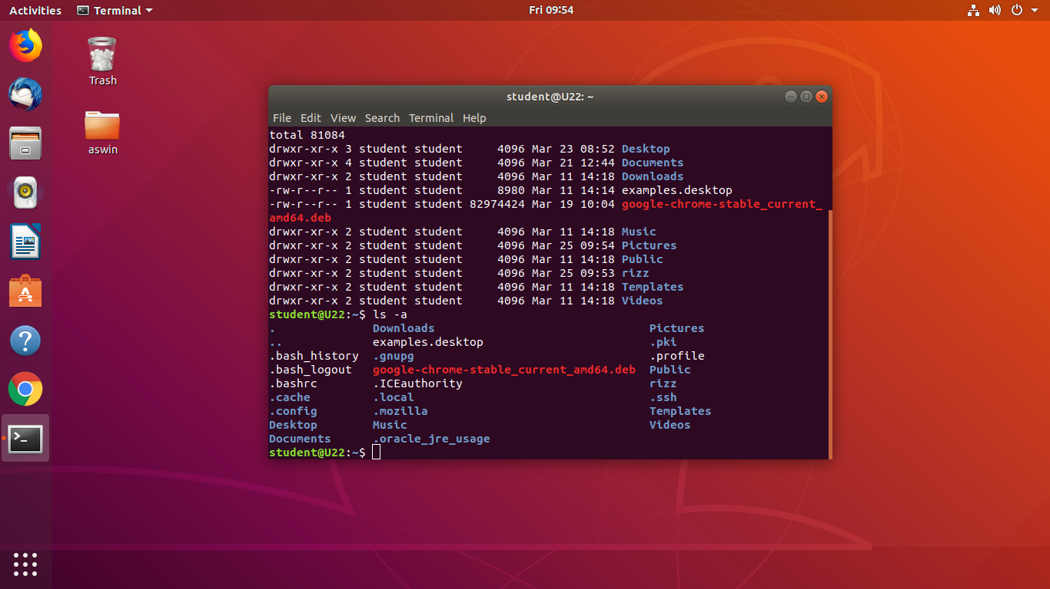

**7. ls –al**

This command is used to

**Syntax :-** $ ls -al

**Output :-**

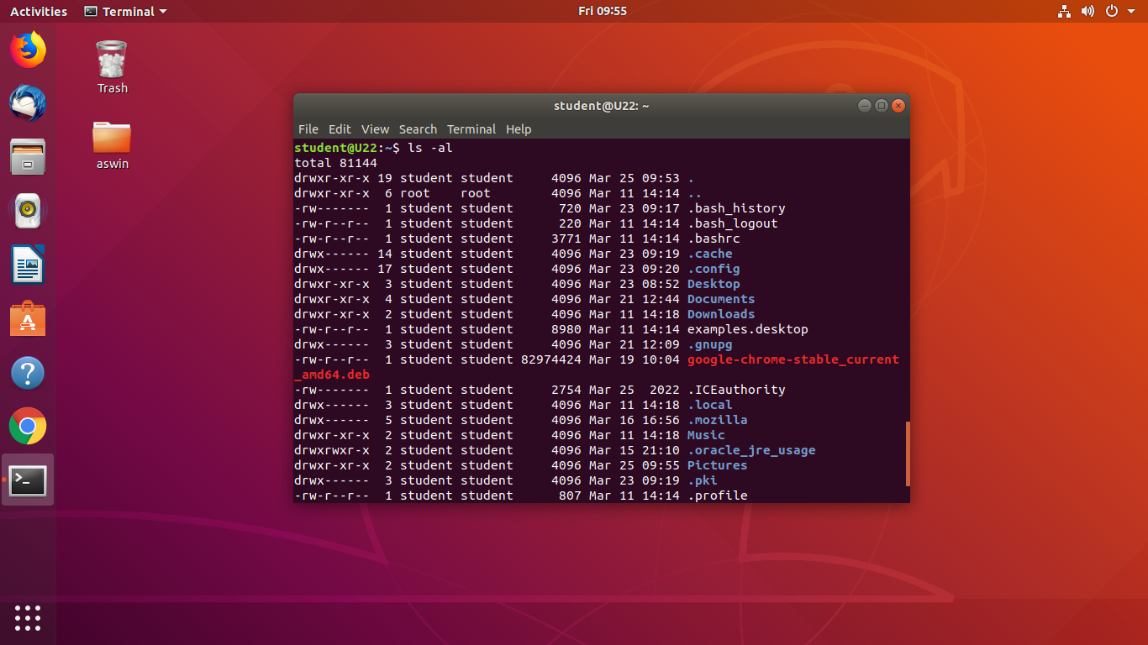

**8.ls -R**

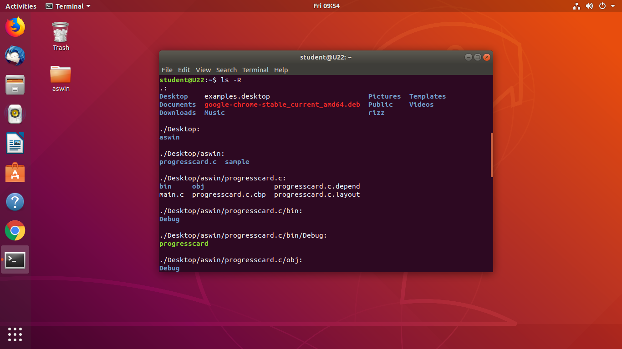

**9.ls -r**

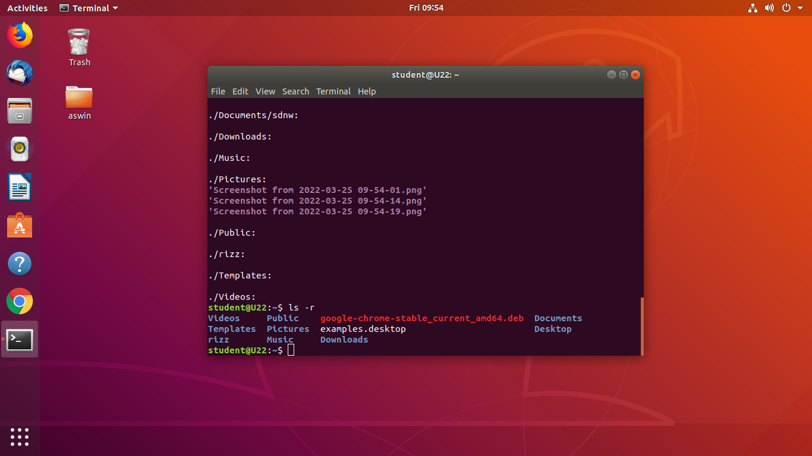

**10. ls –t**

This command is used to display files in the last modified order.

**Syntax :-** $ ls –t

**Output :-**



**11. cd**

This command is used to change the current directory.

**Syntax :-** $ cd <directory name>

**Output :-**

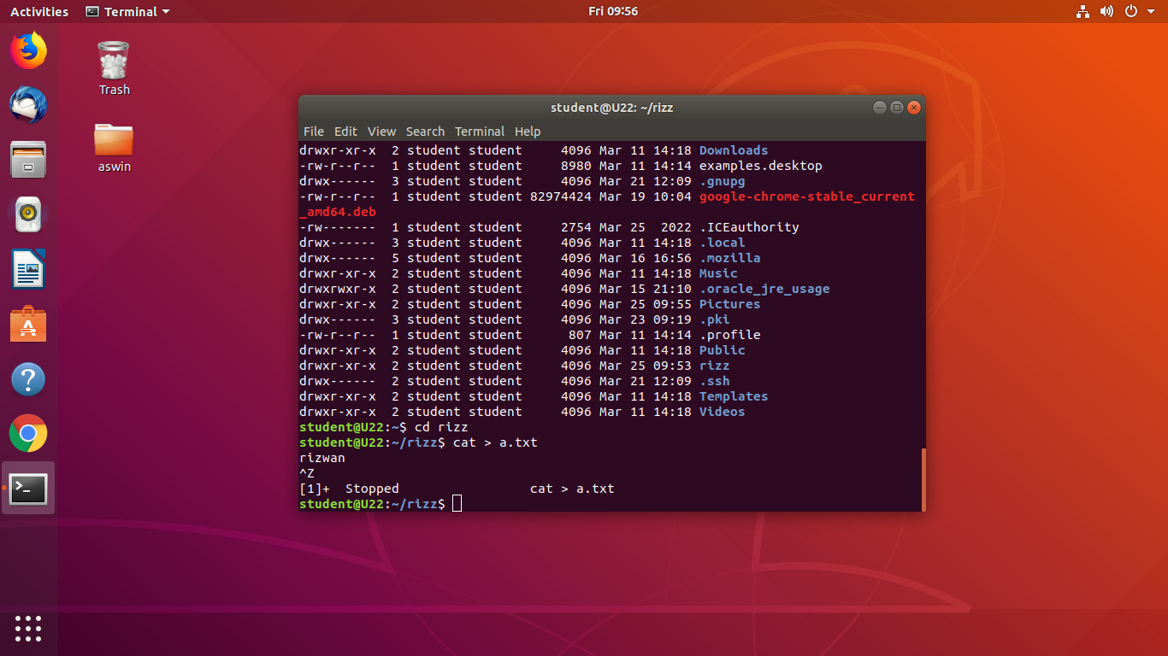

**12. cd ..**

This command is used to move to the parent directory of current directory, or the directory one level up from the current directory.

**Syntax :-** $ cd ..

**Output :-**

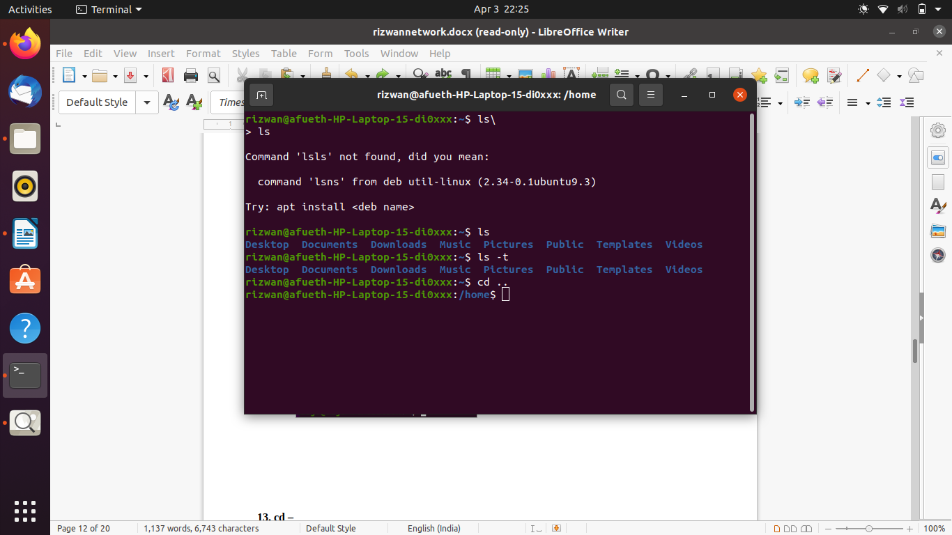

**13. cd –**

This command is used to switch back to previous directory we were working earlier.

**Syntax :-** $ cd –

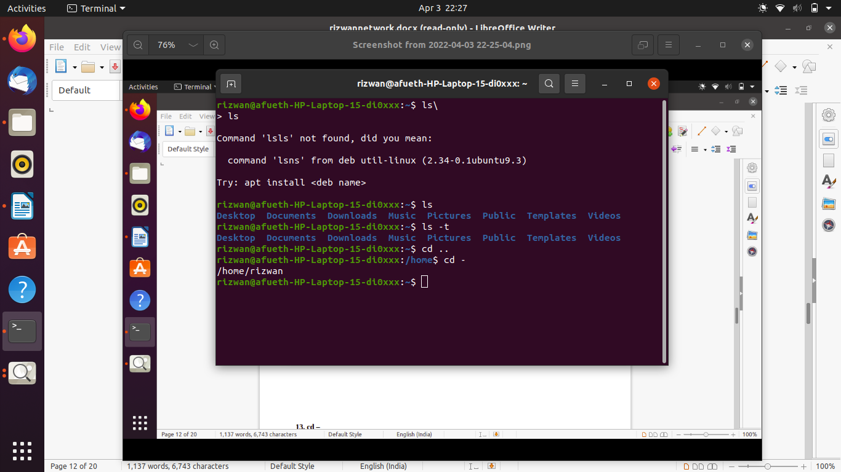**Output :-**

**14. cat > filename**

This command is used to create a file and add contents to that file.

**Syntax :-** $ cat > filename.txt

**Output :-**

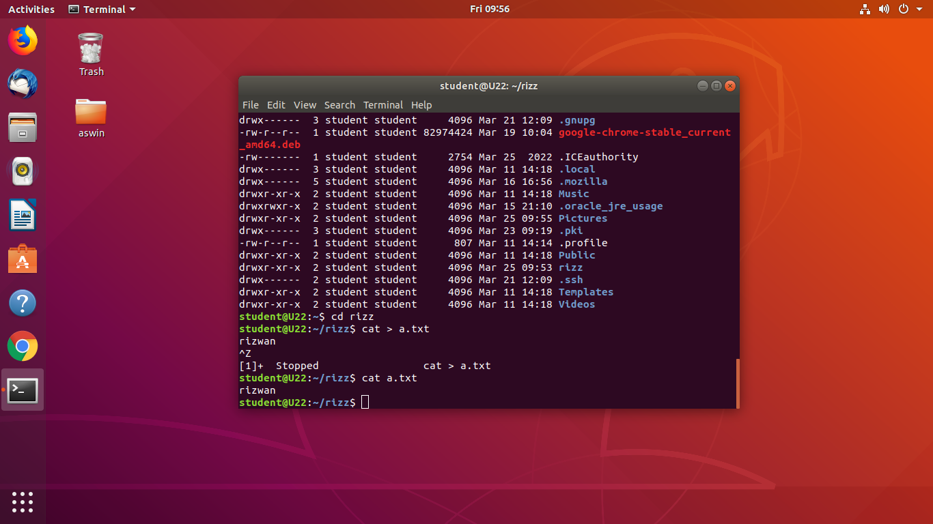

**15. cat>>filename**

This command is used to add contents to an existing file.

**Syntax :-** $ cat >> filename.txt

**Output :-**

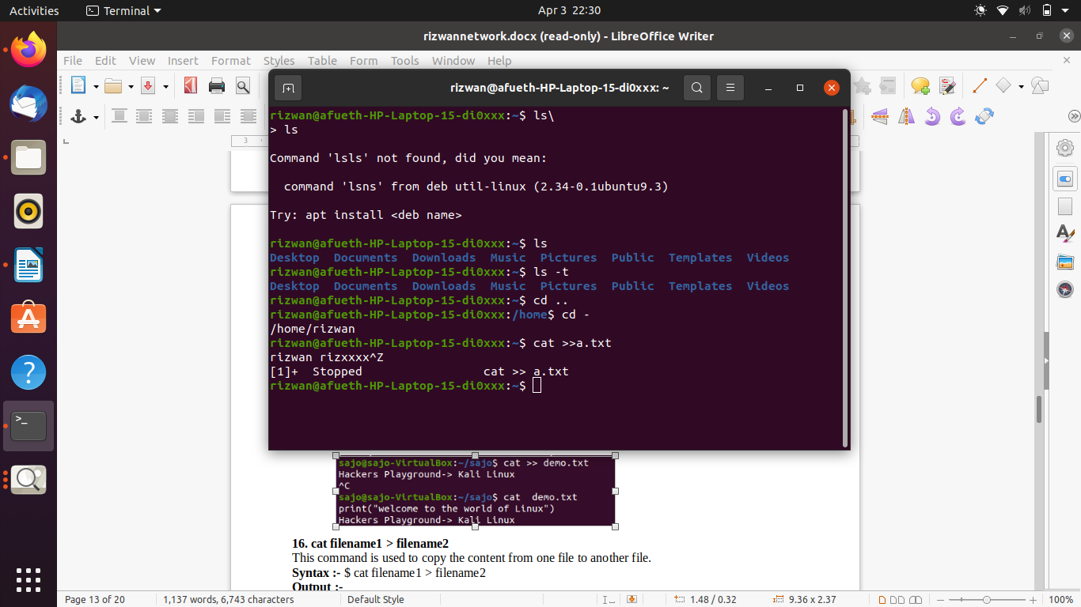

**16. cat filename1 > filename2**

This command is used to copy the content from one file to another file.

**Syntax :-** $ cat filename1 > filename2

**Output :-**

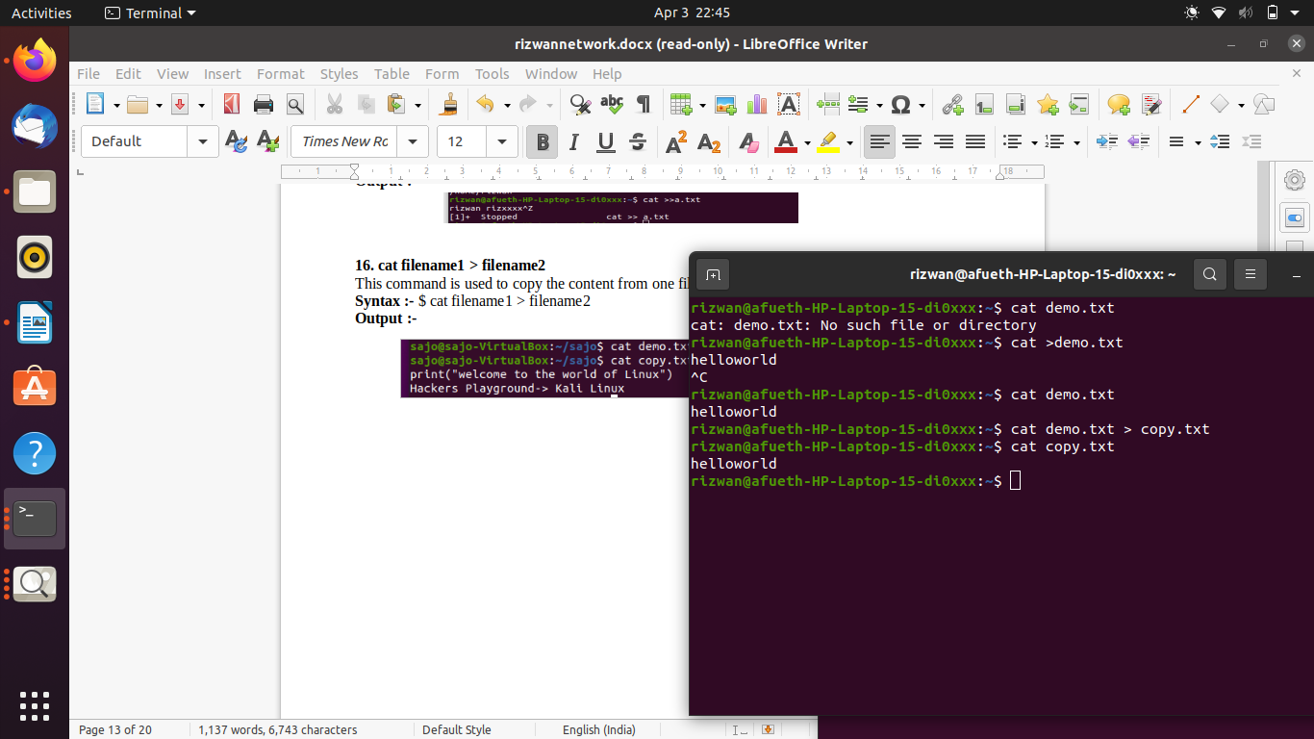

**NETWORKING & SYSTEM ADMINISTRATION LAB**

**Experiment No.: 4**

**Aim**

Familiarization of the Linux commands.

**Procedure**

**1. cat -n**

This command return contents with line numbers.

**Syntax**:- $ cat -n filename

**Output**:-

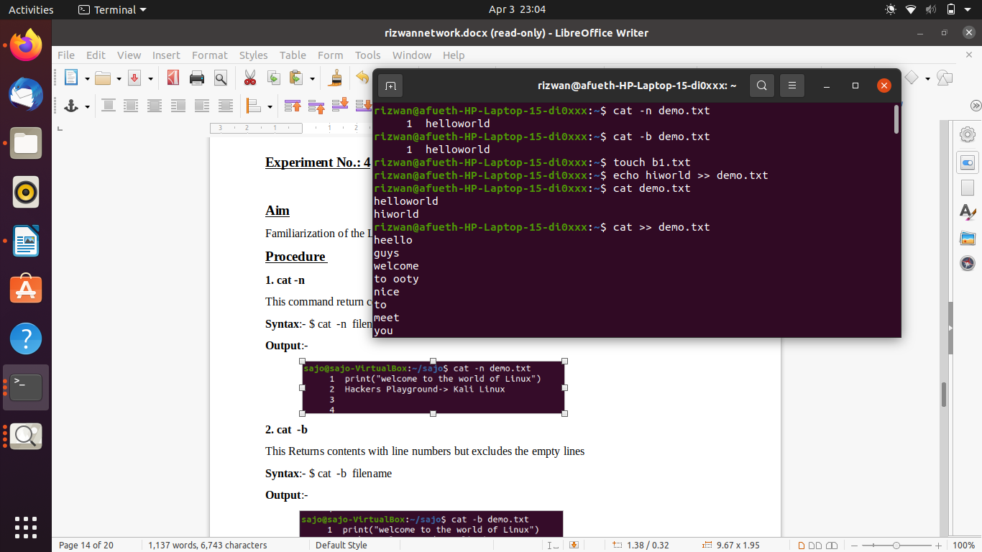

**2. cat -b**

This Returns contents with line numbers but excludes the empty lines

**Syntax**:- $ cat -b filename

**Output**:-



**3. touch**

This command is used to create a empty file

**Syntax**:- $ touch filename

**Output**:-



**4. echo command >> filename**

This command helps to add lines on the empty file

**Syntax**:- $ echo command>> filename

**Output**:-



**5. head**

This command returns first 10 lines in the file

**Syntax**:- $ head filename

**Output**:-

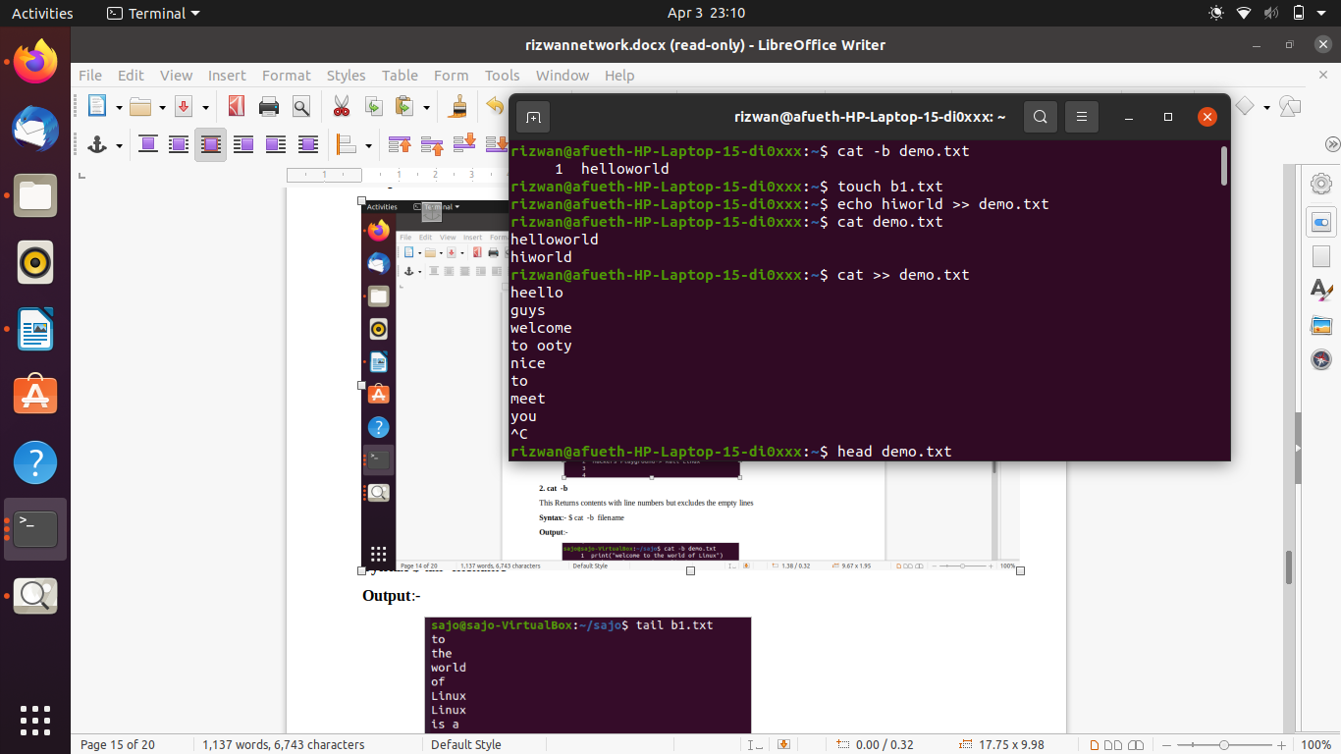

**6. head – (No. of lines)**

This will return beginning lines specified in the command

**Syntax**:- $ head -4 filename

**Output**:-

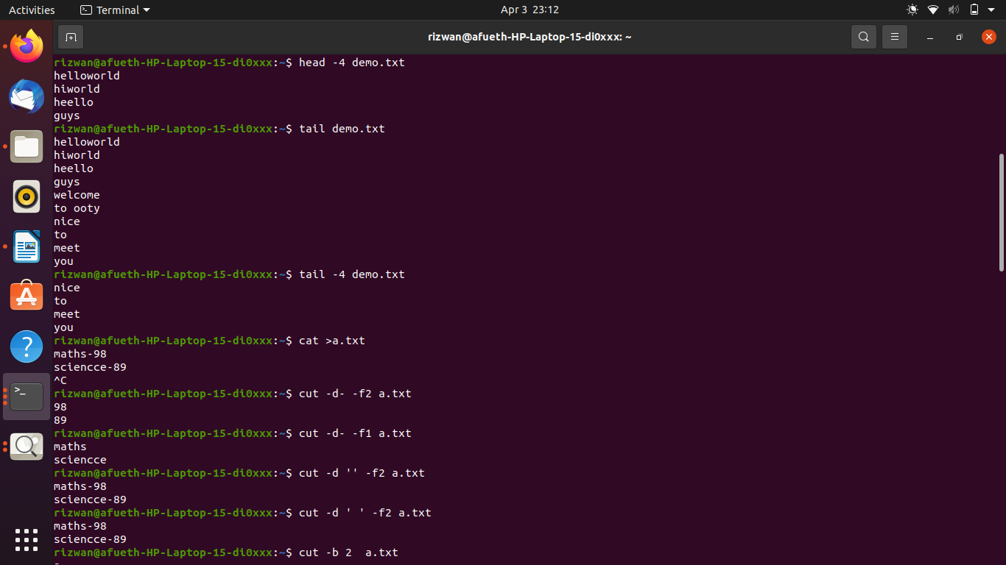

**7. tail**

This returns the last 10 lines in the file

**Syntax** $ tail filename

**Output**:-



**8. tail – (No. of lines)**

This will return last no of lines specified in the command

**Syntax**:- $ tail -4 filename

**Output**:-



**9. cut -f2**

This commands in Linux allows you to select the second part of the content that split by ‘ - ‘ delimiter.

**Syntax**:- $ cut -d- f2 filename

**Output**:-



**10. cut -f1**

This commands in Linux allows you to select the First part of the content that split by ‘ - ‘ delimiter.

**Syntax**:- $ cut -d- f1 filename

**Output**:



**NETWORKING & SYSTEM ADMINISTRATION LAB**

**Experiment No.: 5**

**NAME:RIZWAN**

**ROLL:22**

**BERANCH:22**

**DATE:**

**Aim**

Familiarization of the Linux commands.

**Procedure**

**1. cut -d ‘ ‘ f2**

This commands in Linux allows you to select the second part of the content that split by ‘ ‘ delimiter.

**Syntax:-** $ cut -d ‘ ‘ f2 filename.txt

**Output:-**



**2. cut -b 2**

This command in Linux allows to select only these bytes.

**Syntax:-** $ cut -b 2 filename

**Output:-**

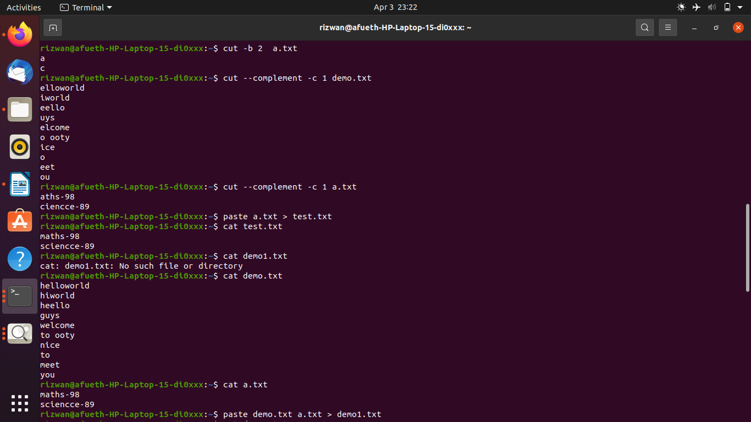

**3.** **cut –complement**

This command helps to exclude given bytes.

**Syntax:-** $ cut –complement -c 1 filename

**Output:-**



**4. paste**

This command helps to paste contents to other file

**Syntax:-** $ paste filename > filename2

**Output:-**



**5. paste a b > c**

This command helps to paste from multiple files.

**Syntax:-** $ paste file1 file2 > file3

**Output:-**

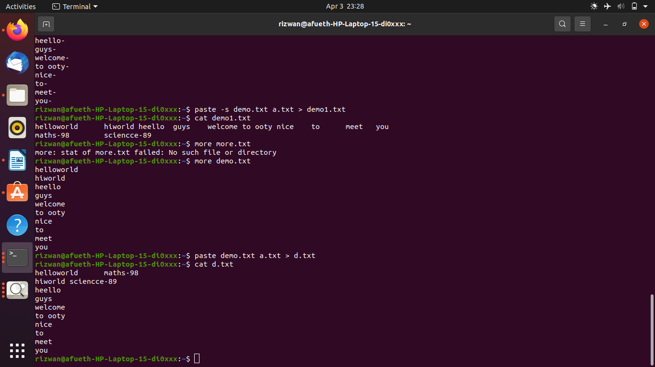

**6. paste -d ‘ ‘**

This command helps to paste contents with ‘ ‘ delimiter.

**Syntax:-** $ paste -d ‘ ‘ file1 file 2 > file3

**Output:-**

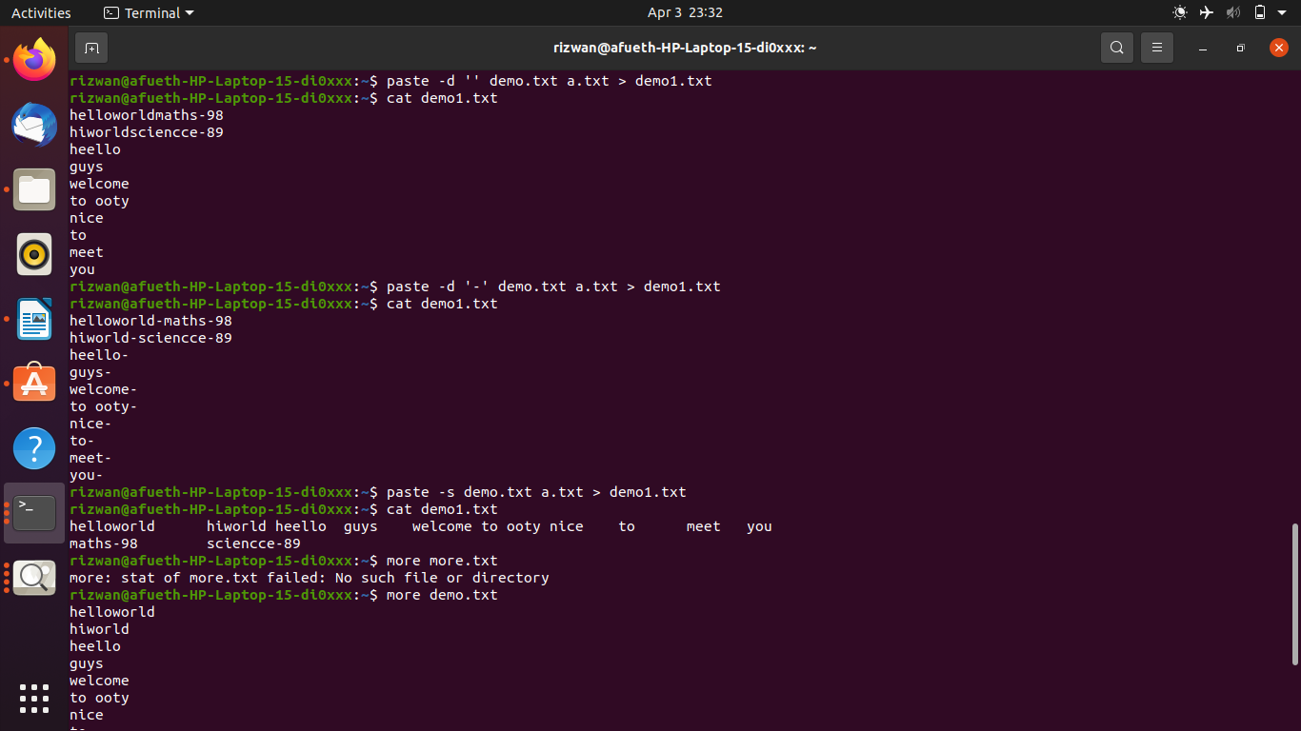

**7. paste -d ‘-‘**

This command helps to contents from multiple files with ‘-‘ delimiter.

**Syntax:-** $ paste -d ‘-‘ file1 file2 > file3

**Output:-**



**8. paste -s**

This command helps to paste on file at a time instead of in parallel.

**Syntax:-** $ paste -s file1 file2 > file3.

**Output:-**



**9. more**

More command is used to view the text files in the command prompt, displaying one screen at a time in case the file is large.

**Syntax:-** $ more filename.

**Output:-**

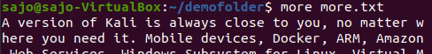

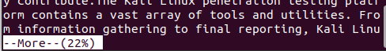

**SPACE Key** is act as a NEXT button.

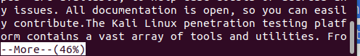

**B Key** act as a PREVIOUS button.

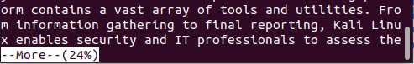

**ENTER** **key** is used to view line by line.

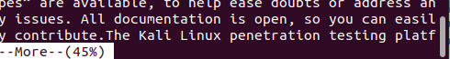

**10. more -s**

This command is used to squeeze multiple blank lines into one.

**Syntax:-** $ more -s filename.

**Output:-**

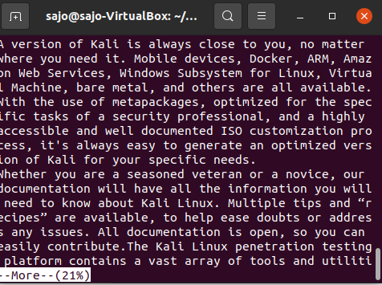

**11. more –(no.)**

This command helps to view content based on specified number of lines.

**Syntax:-** $ more -4 filename.

**Output:-**

